

KEYLOGGER DETECTION SYSTEM

GTUSBTP: 2026(SUBJECTCODE: DI0500011)

STUDENT NAME: SURYAVANSHI ISHWARI VINODBHAI
ENROLLMENT NO: 249720316061
COLLEGENAME:GOVERNMENT POLYTECHCIQUE KHEDA
BRACH CODE: 16
GENDER: FEMALE
REGISTERDMAIL ID:suryavanshivinod820@gamil.com
CONTACT NO: 8141074068


- Project Pruposes (Why Do Made This Project)?

• To Protect Sensitive Data: To prevent the silent theft of critical user information like passwords, credit card numbers, and personal credentials.
• To Identify Hidden Malicious Activities: To expose unauthorized applications running invisibly in the background that are actively monitoring user inputs.
• To Provide Real-Time Defense: To immediately alert users and block key logging attempts the exact moment a suspicious keystroke hook or file-logging action is triggered.
• To Fill Gaps Left by Standard Antivirus: To offer a dedicated layer of security against custom-built or zero-day key loggers that generic security software often misses.

- What Did You Learn in This Program?
• Malware Mechanics: Learned how key logger use system hooks and APIs to silently intercept keyboard inputs.
• Behavioral Detection: Mastered how to flag threats by analyzing live process behaviors rather than relying solely on traditional signatures.
• Process Monitoring: Gained hands-on experience tracking active Process IDs (PIDs) and isolating unauthorized background activity.
• Automated Mitigation: Developed scripts to automatically terminate malicious processes and alert administrators in real time.
• Security Deployment: Learned how to package security tools into standalone executable for real-world deployment.

- Project Objectives (Why Do You Made This Project)?
Identify Stealthy Threats: Detect malicious background applications and unauthorized keyboard hooks that bypass traditional antivirus software.
Monitor System Activity: Continuously track running processes and analyze abnormal system behavior for real-time key logger detection.
Provide Instant Alerts: Instantly notify the user or administrator when a potential key logger or suspicious file is detected.
Enable Threat Mitigation: Offer actionable user controls—such as locating, terminating, or deleting the malicious process or file.
Enhance Cyber security Awareness: Study the working mechanisms of key loggers to educate users on securing their digital environments and protecting their privacy. [1]

- STRUCTURE OF PROJECT

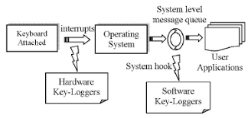
- GIT HUB Link For Project

https://github.com/search?q=keylogger+detection&type=repositories&utm_source=chatgpt.com

- Advantages and Limitation of Project


Advantages of Key logger Detection System Project
- Protects Sensitive Information – Helps prevent theft of passwords, banking details, and personal information.
- Real-Time Detection – Detects suspicious key logger activities while the system is running.
- Improves System Security – Increases overall security by identifying malicious software.
- Early Warning System – Alerts users before the key logger can cause major damage.
- Supports Malware Detection – Detects both known and some unknown key logger behaviors using monitoring techniques.

Limitations of Key logger Detection System
- Cannot Detect All Key loggers – Advanced or newly developed key loggers may bypass detection.
- False Positives – Legitimate applications may sometimes be identified as suspicious.
- Requires Regular Updates – Detection rules and signatures must be updated frequently.
- Limited Against Key loggers – Software-based detection cannot easily detect physical hardware key loggers.
- Performance Overhead – Continuous monitoring may slightly increase CPU and memory usage

- Challenges Faced

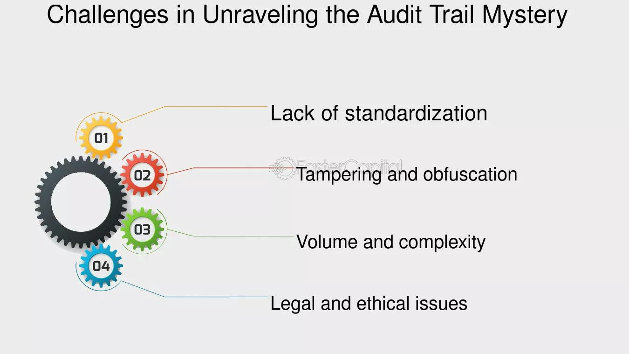

- Conclusion

The Key logger Detection System is an effective cyber security solution designed to identify and detect key logging software that may secretly record user keystrokes. It helps protect sensitive information such as passwords, banking details, and personal data from unauthorized access.
The system continuously monitors running processes and suspicious activities to detect potential keyloggers, improving the overall security of the computer. Although it may not detect every advanced or hardware-based key logger, regular updates and improved detection techniques can significantly enhance its effectiveness.
Overall, the Key logger Detection System is a valuable tool for increasing cyber security awareness, preventing data theft, and protecting users from malicious software. It provides an additional layer of security and contributes to a safer and more secure computing environment.

THANK YOU

